Find us in the heart of Eastbourne in Little Chelsea.
It is easy to access our studio via public transport
and there is parking available at Hyde Gardens, Train Station and Enterprise Centre (5 minutes walk)

Yoga Parties for children and adults available. Please ask for details.

A variety of classes and treatments.

The Yoga-Life Studios provides mats, blocks, straps and blankets for your use during the classes. Dress for comfort.
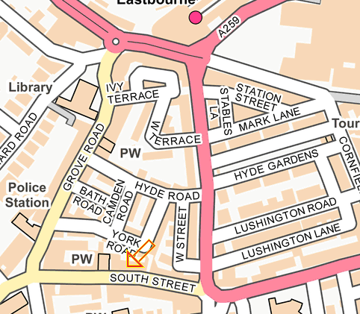

For further details or information:
Studio 4, 25 The Stables
South Street, Eastbourne,
East Sussex, BN21 4UP
07780 535134
info@yoga-life.co.uk
www.yoga-life.co.uk
www.yogaliferetreats.co.uk

Please note, changes in the timetable may occur during school
& national holidays.

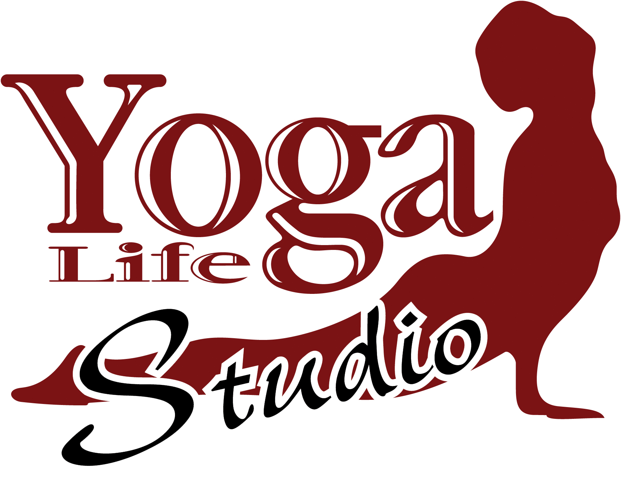

At THE STABLES

Timetable
January – March 2020

Embrace life, feel alive & vibrant
through yoga & alternative lifestyle classes
at our welcoming studio
in the heart of Eastbourne

**Special Events & Workshops – see website**
For further details about any of these classes call the studio on 07780 535134
or the class teacher on the number provided. Email: info@yoga-life.co.uk
Visit www.yoga-life.co.uk for a full list of class descriptions
and weekend workshops on offer.

Monday

9.15am – 10.15am Monday Morning Yoga Fix with Olga Olga
£8.50 drop in or £45/6
11.00am – 12.30pm Ageless Mobility Yoga (55+) Sunny
Slower pace, modifications, £8
please book 07934 188 651
1.00pm – 1.45pm Lunch Yoga Jonathan
Drop in £6
6.15pm – 7.15pm Yin Flow Yoga Sarah Alice
January only £8 drop in
6.00pm – 7.15pm Kundalini Yoga Sian Amy
From February £10 drop in
7.30pm – 8.30pm Chill Out Yoga Aggie
£7 Drop in

Tuesday
9.30am – 10.45am Yoga for Everybody (all abilities) Eva
£8.00 drop-in
11.15am – 12.15pm Mummy and Baby Yoga Alice
£6 or £30/6 – Term time only
12.45pm – 1.45pm Pregnancy Yoga Alice
Drop in £8 or £42/6
6.00pm – 7.00pm Slow Flow for Beginners & Beyond Francesca
Drop in £7 or £50/10 weeks
7.15pm – 8.30pm Healing Yoga: Body, Mind & Spirit Laura
All abilities, £8drop in or £28/4

Wednesday
9.30am – 10.30am Beach Yoga in Holywell Eva
Outdoor Yoga, donations
9.30am – 10.45am Reiki Healing Claire
Book on 07982 119519
10.45am – 11.45am Sweet Circ-Ed Minis Miz
Home-ed class, £45.50 for 7 weeks
11.45am – 12.45pm Sweet Circ-Ed Juniors Miz
Home-ed class, £45.50 for 7 weeks
1.00pm – 1.45pm Lunchtime Yoga – drop in, £6 Eva
2.00pm – 2.45pm Yoga Nidra (Relaxation) & Sound healing Eva
Peace and deep relaxation; £6
6.00pm – 7.15pm Beginners Yoga Ruth
6 week blocks £45 or £8drop in
7.30pm – 9pm Vinyasa Flow (all levels) Fiona
Breath & movement towards dynamic
asana, £8 drop in

Thursday

9.45am - 10.45am Back2Basics Yoga Jonathan
Gentle Yoga suitable for beginners, £7
11.15am – 12.15pm BodyStrong Kat
Whole Body Strength/Flexibility Workout£7 drop in
1.00pm – 3.00pm Reiki Healing Claire
Book on 07982 119519
5.15pm – 6.15pm Yoga Nidra Georgina/Chantell
Cake & Kindness for stress relief Drop in £8.50
6.30pm – 7.30pm Pregnancy Yoga Alice
Drop in £8 or £42/6
7.45pm – 8.45pm Yin Yoga Mel
Suitable for all, dynamic relaxation practice £8 drop in

Friday

10.00am – 11.00am Gentle Hatha Yoga – Let go of the week Safia
£8.00 drop-in £28/4
1.00pm – 1.45pm Lunchtime Restorative Yoga Eva
Restore & relax; £6 Drop In
2.00pm – 2.45pm Meditation, Relaxation & Breath Eva
Peace and tranquillity, £6
5.00pm – 6.00pm Circus Monkeys – Mixed Aerial Miz
Age 5-15, £45.50 for 7 weeks
6.30pm – 7.30pm Beginners Yoga Chantell
£7 drop in / £40 for 6 weeks block

Saturday
9.00am – 10.30am Flow & Restore Yoga Lucy
Strong and slow Flow class, £8 drop in
11.00am – 12.00pm Rest & Digest Yoga Tanya
£7 Drop in
1.00pm – 2.00pm Community Yoga Various
Donation class, proceeds to charity
Sunday
9.00am – 10.00am Setup your Sunday Yoga Angela
Yoga for All abilities, £7 drop in
11.15am-12.30pm Yoga for Everybody (all abilities) Eva
£8 Drop In
1.30pm – 5.00pm Reiki Healing Claire
Book on 07982 119519
6.00pm – 7.00pm Beginners Yoga Laura Hall
£7 drop in

