Find us in the heart of Eastbourne in Little Chelsea.
It is easy to access our studio via public transport
and there is parking available at Hyde Gardens, Train Station and Enterprise Centre (5 minutes walk)

Yoga Parties for children and adults available. Please ask for details.

A variety of classes and treatments.

The Yoga-Life Studios provides mats, blocks, straps and blankets for your use during the classes. Dress for comfort.
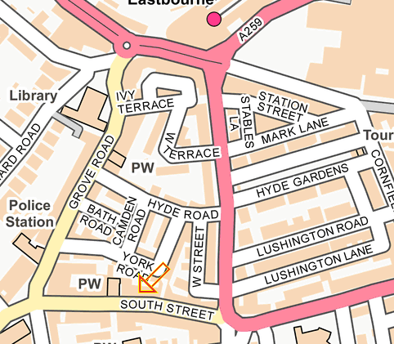

For further details or information:
Studio 4, 25 The Stables
South Street, Eastbourne,
East Sussex, BN21 4UP
07780 535134
info@yoga-life.co.uk
www.yoga-life.co.uk
www.yogaliferetreats.co.uk

Please note, changes in the timetable may occur during school
& national holidays.

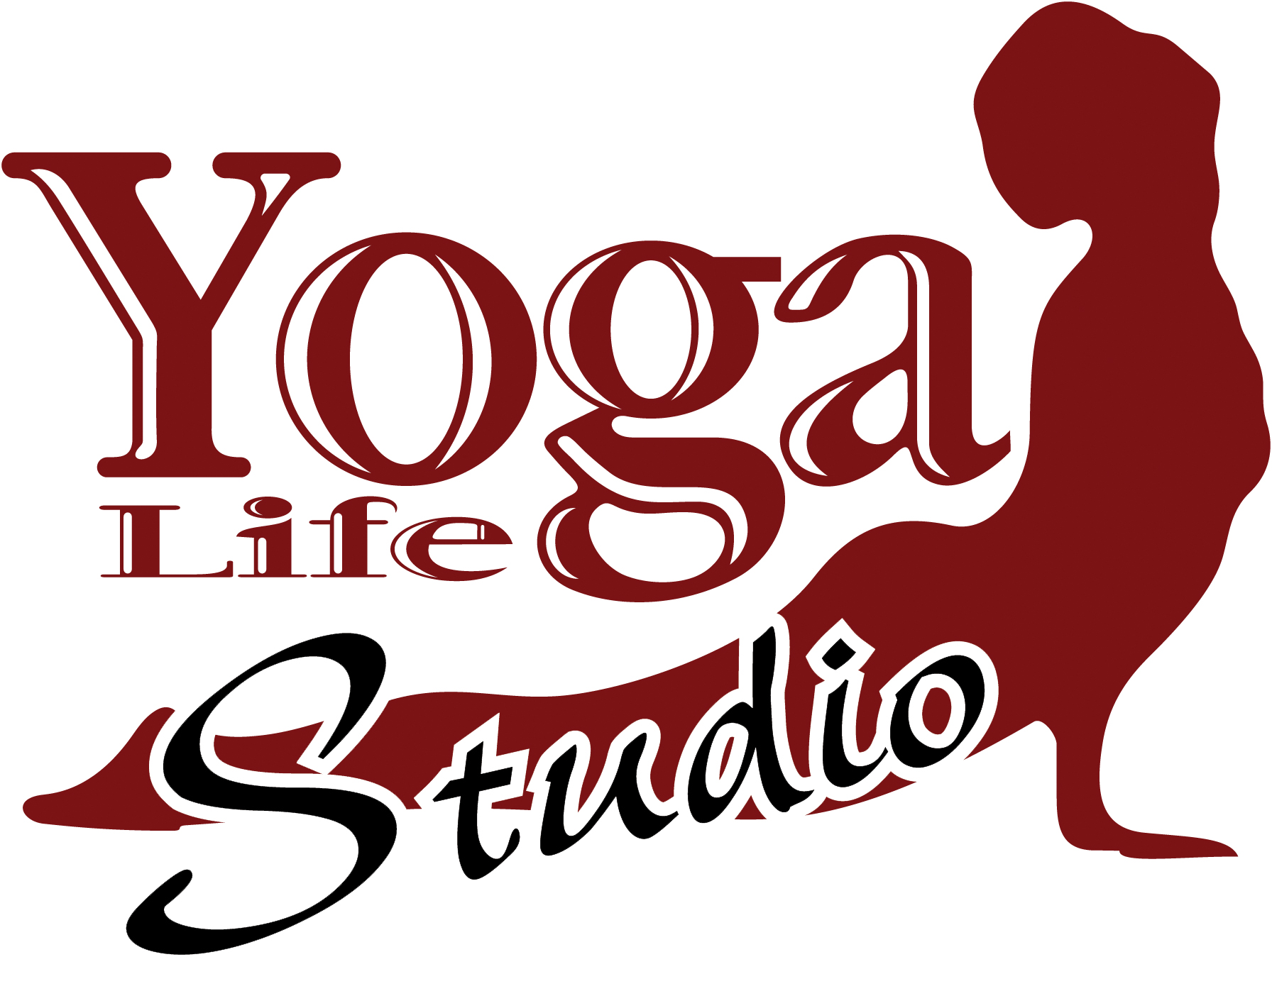

At THE STABLES

Timetable
January – March 2019

Embrace life, feel alive & vibrant
through yoga & alternative lifestyle classes
at our welcoming studio
in the heart of Eastbourne

**Special Events & Workshops – see website**
For further details about any of these classes call the studio on 07780 535134
or the class teacher on the number provided. Email: info@yoga-life.co.uk
Visit www.yoga-life.co.uk for a full list of class descriptions
and weekend workshops on offer.

Monday
7.00am – 8.00am Rise & Shine - Morning Yoga Flow Gracie
Drop in £8
10.30am – 12.00pm Slow Yoga Coaching for Third Agers (55+) Sunny
Slower pace, modifications, £7
please book 07934 188 651
1.00pm – 1.45pm Lunch Yoga Jonathan
Drop in £6
3.30pm – 4.15pm Hang Out Yoga for Teens Eva
7/1 – 11/2 Yoga fun for teens incl. Aerial £35 6 weeks
4.00pm – 5.00pm Tween Yoga for Girls 8-12 yo Jane

6.15pm – 7.15pm Vinyasa Flow Yoga Chloe
£7 drop in
7.30pm – 8.30pm Chill Out Yoga Aggie
£7 Drop in, 1st class only £1

Tuesday
9.30am – 10.45am Yoga for Everybody (all abilities) Eva
£8.00 drop-in
11.15am – 12.15pm Mummy and Baby Yoga Alice
£6 or £30/6 – Term time only
1.00pm – 1.45pm Lunchtime Yoga Alice
£6.00 drop-in
4.00pm – 5.00pm Gentle Yoga & Relaxation Zoe
£7 drop in
5.45pm – 6.45pm Rocket Yoga Hanif
£7.00 drop-in
7.15pm – 8.30pm Healing Yoga: Body, Mind & Spirit Laura
All abilities, £8drop in or £28/4

Wednesday
8.00am – 9.00am Rise & Shine - Morning Yoga Flow Gracie
Drop in £8
9.30am – 10.30am Beach Yoga in Holywell Retreat Eva
Outdoor Yoga, donations
9.30am – 12.30pm Reiki Healing Claire
Book on 07982 119519
1.00pm – 1.45pm Lunchtime Yoga – drop in, £6 Eva
2.00pm – 2.45pm Yoga Nidra (Relaxation) & Sound healing Eva
Peace and deep relaxation; £6
6.00pm – 7.15pm Beginners Yoga Ruth
6 week blocks £45 or £8drop in
7.30pm – 9pm Vinyasa Flow (all levels) Fiona
Breath & movement towards dynamic
asana, £8 drop in

Thursday
9.45am - 10.45am Back2Basics Yoga Jonathan
Gentle Yoga suitable for beginners, £7
11.15am – 12.15pm Tai Chi Qigong 4 week course Nick Neter
10/1 – 31/1 £32 for the course – book on 07773 061309
11.30am – 12.30pm Reiki Healing Claire
Book on 07982 119519
1.00pm – 2.00pm BodyStrong Kat
£7 drop in
5.15pm – 6.15pm Chakra Yoga Mel
£7.50 drop in (£5 first class)
6.30pm – 7.30pm Pregnancy Yoga Alice
From 10/1 Drop in £8 or £42/6
8.00pm – 9.30pm Total Relaxation - Restorative Yoga & Yoga Nidra
£8 drop in or £42 block of 6 Claire K

Friday
8.00am – 9.30am Womb Yoga Mala
From 11/1 Yoga Therapy for women, £10
10.00am – 11.00am Gentle Hatha Yoga – Let go of the week Safia
£8.00 drop-in £28/4
1.00pm – 1.45pm Lunchtime Restorative Yoga Eva
Restore & relax; £6 Drop In
2.00pm – 2.45pm Meditation, Relaxation & Breath Eva
Peace and tranquillity, £6
3.00pm – 5.00pm Indian Head Massage Jonathan
45 mins £25, 1 hour £30. Book – 07745 894982
6.30pm – 8.00pm Womb Yoga Mala
From 11/1 Yoga Therapy for women, £10
Saturday
9.00am – 10.30am Hatha Yoga Abigail
£8 per adult, Drop in
11.00am – 12.00pm Rest & Digest Yoga Tanya
£6 Drop in
1.00pm – 2.00pm Community Yoga Various
Donation class, proceeds to charity
Sunday
9.30am – 10.45am Pregnancy Yoga Vicky
Block of 6 £60, call to book 07566 228445
11.15am-12.30pm Yoga for Everybody (all abilities) Eva
£8 Drop In
1.30pm – 5.00pm Reiki Healing Claire
Book on 07982 119519

