Find us in the heart of Eastbourne at the Enterprise Centre.
It is easy to access our studio via public transport
and there is parking available. The entrance to the studio in the evenings is at the back of the building (Yoga buzzer upstairs).

Yoga Parties for children and adults available. Please ask for details.

A variety of classes and alternative treatments.

The Yoga-Life Studios provides mats, blocks, straps and blankets for your use during the classes. Dress for comfort.
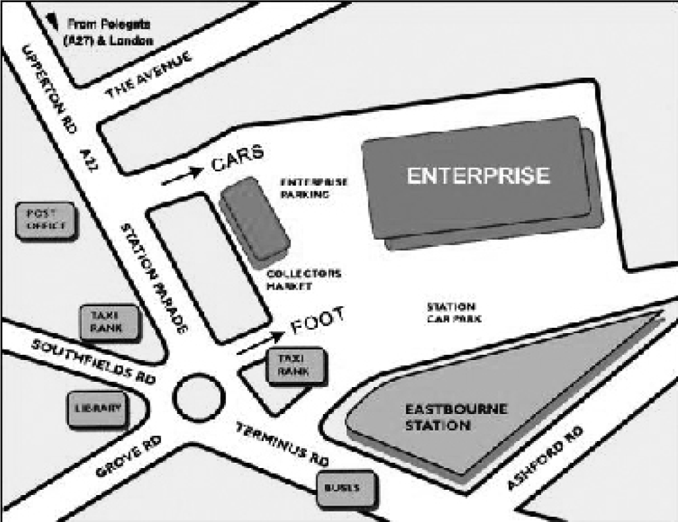

For further details or information:
Upstairs at The Enterprise Centre
Station Parade, Eastbourne,
East Sussex, BN21 1BD
07812 052742
info@yoga-life.co.uk
www.yoga-life.co.uk
www.yogaliferetreats.co.uk

Please note, changes in the timetable may occur during school
& national holidays.

Yoga Life
Studio

Timetable
July - September 2018

Embrace life, feel alive &
vibrant
through yoga & alternative
lifestyle classes at our welcoming studio in the
heart of Eastbourne

**Special Events & Workshops – see website**
For further details about any of these classes call the studio on 07812 052742
or the class teacher on the number provided. Email: info@yoga-life.co.uk
Alternatively visit www.yoga-life.co.uk for a full list of class descriptions and weekend workshops on offer.

Monday
9.30am – 10.30am Beach Yoga in Holywell Retreat Simon
Outdoor Yoga, donations
11.00am – 12.30pm Slow Yoga Coaching for Third Agers (55+) Sunny
Slower pace, modifications, £7
please book 07934 188 651
1.00pm – 1.45pm Lunch Yoga Jonathan
Drop in £6
2.00pm – 5.00pm Reiki Healing Claire
Book on 07982 119519
7.30pm – 9.00pm Yin Yoga and Nidra for all (£8) Sunny
Deep tissue work, long relaxation - book on 07934 188651

Tuesday
9.30am – 10.45am Yoga for Everybody (all abilities) Eva
£8.00 drop-in
11.15am – 12.15pm Mummy Yoga – Mixed Alice
Bring babies/toddlers; £5 or £25/6
1.00pm – 1.45pm Lunchtime Yoga Alice
£6.00 drop-in
5.45pm – 6.45pm Flexibility Flow Yoga Katherine
Breathe-Dynamic stretching-Static holds £7.00 drop-in
7.15pm – 8.30pm Healing Yoga: Body, Mind & Spirit Laura/Aggie
All abilities, £8drop in or £28/4

Wednesday
9.30am – 10.30am Beach Yoga in Holywell Retreat Eva
Outdoor Yoga, donations
10.00am – 11.15am Sweet Circus – Circus Tots Miz
Circus themed active play, £5 (1 adult + child)
11.15am – 12.30pm Sweet Circus – Sweet Circ-Ed (Home Ed) Miz
Circus themed activity, £7.50 / £6
Sweet Circus drop in session 10.30 – 12 during school holidays
1.00pm – 1.45pm Lunchtime Yoga – drop in, £6 Eva
2.00pm – 2.45pm Yoga Nidra (Relaxation) & Sound healing Eva
Check website during hols Peace and deep relaxation; £6
3.45pm – 4.45pm Sweet Circus – Circus Monkeys (6-10 yo) Miz
Circus themed activity, £7.50 / £6
Sweet Circus Summer School 3.30 – 5.00pm during school holidays
4.45pm – 5.45pm Sweet Circus – Circus Monkeys (11+) Miz
Circus themed activity, £7.50 / £6
6.00pm – 7.15pm Beginners Yoga Ruth
6 week blocks £45 or £8drop in
7.30pm – 9pm Vinyasa Flow (all levels) Fiona
Breath & movement towards dynamic
asana, £8 drop in

Thursday

9.45am - 10.45am Back2Basics Yoga Jonathan
Gentle Yoga suitable for beginners, £7
5.15pm – 6.15pm Chakra Yoga Mel
From September £7 or £30/6
6.30pm – 7.30pm Flow Yoga Alice
Drop in £7 or £35/6
8.00pm – 9.30pm Total Relaxation - Restorative Yoga & Yoga Nidra
£8 drop in or £42 block of 6 Claire K

Friday
10.00am – 11.00am Gentle Hatha Yoga – Let go of the week Safia
£7.00 drop-in / £24 4-week bl.
1.00pm – 1.45pm Lunchtime Restorative Yoga Eva
Restore & relax; £6 Drop In
2.00pm – 2.45pm Meditation, Relaxation & Breath Eva
Check website during hols Peace and tranquillity, £6
3.00pm – 5.00pm Indian Head Massage Jonathan
45 mins £25, 1 hour £30. Book – 07745 894982
3.00pm – 5.00pm Reiki Healing Claire
Book on 07982 119519

Saturday

9.30am – 10.30am Beach Yoga in Holywell Retreat Sarah
Outdoor Yoga, donations
£5 per adult, Drop in
Sunday
9.30am – 10.45am Pregnancy Yoga Vicky
Block of 6 £60, call to book 07566 228445
11.15am-12.30pm Yoga for Everybody (all abilities) Eva
£7 Drop In or £36 6-week block
1.30pm – 5.00pm Reiki Healing Claire
Book on 07982 119519
6.30pm – 7.30pm Yoga for Everybody (all abilities) Sarah
£7 Drop In
8.00pm – 9.00pm Chill Out Yoga Aggie
From 26/8 £7 Drop in, 1st class only £1

