Find us in the heart of Eastbourne at the Enterprise Centre.
It is easy to access our studio via public transport
and there is parking available. The entrance to the studio in the evenings is at the back of the building (Yoga buzzer upstairs).

Yoga Parties for children and adults available. Please ask for details.

A variety of classes and alternative treatments.

The Yoga-Life Studios provides mats, blocks, straps and blankets for your use during the classes. Dress for comfort.
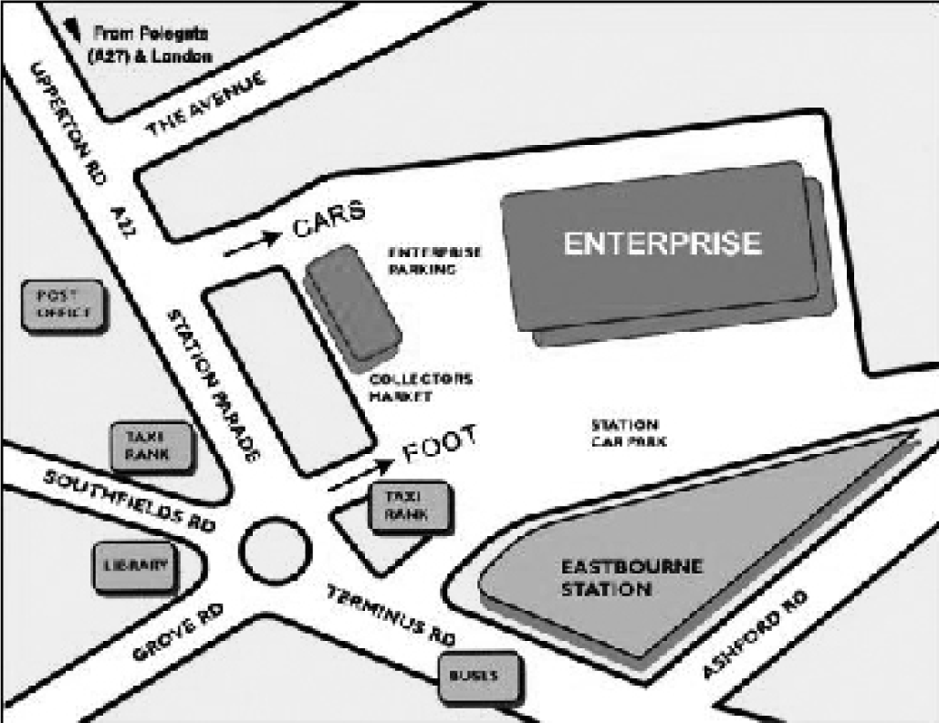

For further details or information:
Upstairs at The Enterprise Centre
Station Parade, Eastbourne,
East Sussex, BN21 1BD
07812 052742
info@yoga-life.co.uk
www.yoga-life.co.uk
www.yogaliferetreats.co.uk

Please note, changes in the timetable may occur during school
& national holidays.

Yoga Life
Studio

Timetable
October - December 2017

Embrace life, feel alive &
vibrant
through yoga & alternative
lifestyle classes at our luxurious
and welcoming studio in the
heart of Eastbourne

**Special Events & Workshops – see website**
For further details about any of these classes call the studio on 07812 052742
or the class teacher on the number provided. Email: info@yoga-life.co.uk
Alternatively visit www.yoga-life.co.uk for a full list of class descriptions and weekend workshops on offer.

Monday

9.30am – 10.45am Energising Flow Yoga Katherine
£8.00 drop-in
9.30am – 10.30am Beach Yoga in Holywell Retreat Simon
Outdoor Yoga, donations
11.00am – 12.15pm Slow Yoga Coaching – Beginners/Elders Sunny
Slower pace, modifications, £6 drop in
1.00pm – 1.45pm Lunch Yoga Jonathan
Drop in £6
6.00pm – 7.15pm Ashtanga Vinyasa Flow Hanif
Drop in £6
7.30pm – 8.30pm Vinyasa Flow Yoga Annie
Drop in £8

Tuesday

9.30am – 10.45am Yoga for Everybody (all abilities) Eva
£8.00 drop-in
11.15am – 12.15pm Mummy Yoga – Mixed Eva
For mums to be/babies/toddlers; £5 or £25/6
1.00pm – 1.45pm Lunchtime Yoga Vicky
£6.00 drop-in
2.00pm – 3.15pm Slow Functional Yoga for Beginners Sunny
4 spaces only, £8, many modifications
book on 07934 1886151
4.00pm – 5.00pm Pregnancy Yoga Vicky
Relaxing class for mums to be, £8
6.00pm – 7.00pm Rocket Yoga Emily
Drop in £5
7.15pm – 8.30pm Healing Yoga: Body, Mind & Spirit Laura
All abilities, £8drop in or £28/4

Wednesday

9.15am – 12.45pm Reiki Healing Claire
Book on 07982 119519
9.30am – 10.30am Beach Yoga in Holywell Retreat Eva
Outdoor Yoga, donations
1.00pm – 1.45pm Lunchtime Yoga – drop in, £6 Eva
2.00pm – 2.45pm Yoga Nidra (Relaxation) & Sound healing Eva
Peace and deep relaxation; £6
6.00pm – 7.15pm Beginners Yoga Ruth
6 week blocks £45 or £8drop in
7.30pm – 9pm Vinyasa Flow (all levels) Fiona
Breath & movement towards dynamic
asana, £8 drop in

Thursday
9.45am - 10.45am Back2Basics Yoga Jonathan
Gentle Yoga suitable for beginners, £7
11.00am – 12.00noon Qigong and Meditation Nick
1st Thursday of a month – Italian Gardens! £5 drop in
5.15pm – 6.15pm Yoga for Everybody (All abilities) Laura
Drop in £6
6.30pm – 7.30pm Align & Breathe Yoga Linzi
£7.50 drop in or £40 for 6 week block
Alignment based vinyasa, £8 drop in

Friday

10.00am – 11.00am Gentle Hatha Yoga – Let go of the week Safia
£7.00 drop-in / £24 4-week bl.
11.15am – 12.30pm Energising Flow Yoga Katherine
£8.00 drop-in
1.00pm – 1.45pm Lunchtime Restorative Yoga Eva
Restore & relax; £6 Drop In
2.00pm – 2.45pm Meditation, Relaxation & Breath Eva
Peace and tranquillity, £6
3.00pm – 5.45pm Indian Head Massage Jonathan
45 mins £25, 1 hour £30. Book – 07745 894982
6.00pm – 7.15pm Rocket Yoga Hanif
Level 1 & 2, £5 drop in
7.30pm – 8.45pm Gentle Hatha Yoga Sarah (Love Yoga
Drop in £8 Eastbourne)

Saturday

8.45am – 9.45am Luna Yoga Sally
£8 drop-in / £42 6-week bl.
9.30am – 10.30am Beach Yoga in Holywell Retreat Sarah
Outdoor Yoga, donations
10.00am-11.00am Family Yoga Alice/Heather
£5 per adult, Drop in

Sunday

10/00am – 11.00am Aerial Yoga Eva
£8 – check website for dates
11.15am-12.30pm Yoga for Everybody (all abilities) Eva
£7 Drop In or £36 6-week block
1.00pm – 4.00pm Reiki Healing Claire
Book on 07982 119519

