Find us in the heart of Eastbourne at the Enterprise Centre.
It is easy to access our studio via public transport
and there is parking available. The entrance to the studio in the evenings is at the back of the building (Yoga buzzer upstairs).

Yoga Parties for children and adults available. Please ask for details.

A variety of classes and alternative treatments.

The Yoga-Life Studios provides mats, blocks, straps and blankets for your use during the classes. Dress for comfort.
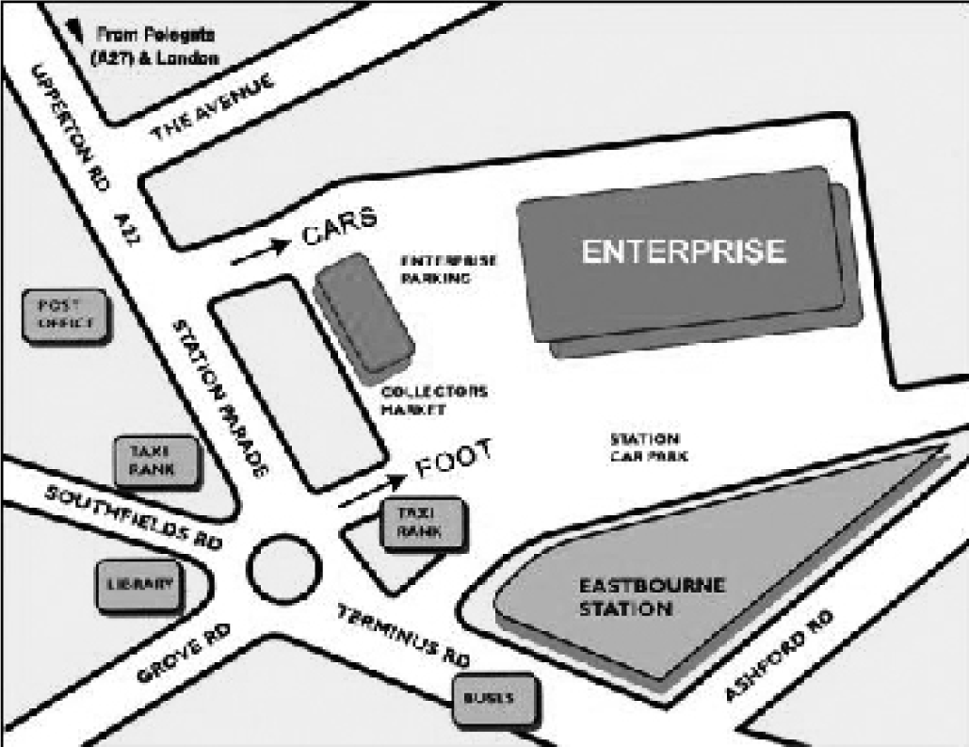

For further details or information:
Upstairs at The Enterprise Centre
Station Parade, Eastbourne,
East Sussex, BN21 1BD
07812 052742
info@yoga-life.co.uk
www.yoga-life.co.uk
www.yogaliferetreats.co.uk

Please note, changes in the timetable may occur during school
& national holidays.

Yoga Life
Studios

Timetable
April - June 2017

Embrace life, feel alive &
vibrant
through yoga & alternative
lifestyle classes at our luxurious
and welcoming studio in the
heart of Eastbourne

**Special Events & Workshops – see website**
For further details about any of these classes call the studio on 07812 052742
or the class teacher on the number provided. Email: info@yoga-life.co.uk
Alternatively visit www.yoga-life.co.uk for a full list of class descriptions and weekend workshops on offer.

MAIN STUDIO

Monday

9.45am – 10.45am Shakti Flow Yoga Tess
Alignment based vinyasa, £6 drop in
11.00am – 12.00noon Yoga for the Golden Years (seniors) Tess
Slower pace, modifications, £6 drop in
1.00pm – 1.45pm Lunch Yoga Jonathan
Drop in £6
6.00pm – 7.15pm Ashtanga Vinyasa Flow Hanif
Drop in £6
7.30pm – 8.30pm Vinyasa Flow Yoga Annie
Drop in £8

Tuesday

9.30am – 10.45am Yoga for Everybody (all abilities) Eva / Wenche
£8.00 drop-in
11.15am – 12.15pm Mummy Yoga – Mixed Eva
For mums to be/babies/toddlers; £5 or £25/6
1.00pm – 1.45pm Lunchtime Yoga Vicky
£6.00 drop-in
6.00pm – 7.00pm Rocket Yoga Emily
Drop in £5
7.15pm – 8.30pm Healing Yoga: Body, Mind & Spirit Laura
All abilities, £8drop in or £28/4

Wednesday

9.15am – 12.30pm Reiki Healing Claire
Book on 07982 119519
9.30am – 10.30am Beach Yoga in Holywell Retreat Eva
Outdoor Yoga, donations
12.15pm – 12.45pm Pregnancy Relaxation Dannii
£5 drop in
1.00pm – 1.45pm Lunchtime Yoga – drop in, £6 Eva
6.00pm – 7.15pm Beginners Yoga Ruth
6 week blocks £45 or £8drop in
7.30pm – 9pm Vinyasa Flow (all levels) Fiona
Breath & movement towards dynamic
asana, £8 drop in

Thursday

9.45am - -10.45am Back2Basics Yoga Jonathan
Gentle Yoga suitable for beginners, £7
11.00am – 12.00noon Qigong and Meditation Nick
1st Thursday of a month – Italian Gardens! £5 drop in
12.30pm – 1.30pm Pregnancy Yoga – for Mummies to be Laura
£7 drop in or £25/4
5.15pm – 6.15pm Yoga for Everybody (All abilities) Laura
From May Drop in £6
6.30pm – 7.30pm Align & Breathe Yoga Linzi
£7.50 drop in or £40 for 6 week block
7.45pm – 9.15pm Shakti Flow Yoga Tess
Alignment based vinyasa, £8 drop in
Friday
10.00am – 11.00am Gentle Hatha Yoga – Let go of the week Safia
£7.00 drop-in / £24 4-week bl.
11.15am – 12.15pm Energising Flow Yoga Katherine
£7.00 drop-in
1.00pm – 1.45pm Lunchtime Restorative Yoga Eva
Restore & relax; £6 Drop In
2.00pm – 2.45pm Meditation, Pranayama & Relaxation Eva
Calm your mind & breathe; £5
3.00pm – 5.45pm Indian Head Massage Jonathan
45 mins £25, 1 hour £30. Book – 07745 894982
6.00pm – 7.15pm Rocket Yoga Hanif
Level 1 & 2, £5 drop in
7.30pm – 8.45pm Gentle Hatha Yoga Sarah (Love Yoga
Drop in £8 Eastbourne)

Saturday
8.45am – 9.45am Luna Yoga Sally
£8 drop-in / £42 6-week bl.
11.30am – 1.00pm Private Group
2.00pm – 4.00pm Aromatherapy / Swedish Massage, Reflexology
Hopi Ear Candling
Call 07967 531924 to book Sue

Sunday
8.30am – 9.30am Sunday Sunrise SatNam Yoga Tess
Kundalini/Shakti/Breath £8 or £42/6
10.00am-11.00am Family Yoga Eva
£5 per adult, Drop in
11.15am-12.30pm Yoga for Everybody (all abilities) Eva
£7 Drop In or £36 6-week block

STUDIO 2 (open in April Only)

Monday

9.15am – 1.15pm Reiki Healing Claire
Book on 07982 119519
5.15pm – 6.30pm Yoga for Everybody (All abilities) Laura
Drop in £6
6.45pm – 8.00pm Hatha Yoga (mixed abilities) Justyna
Till 15/5 £7 or £35 per 6, first class £5

Tuesday

9.30am – 12.30pm Indian Head Massage Jonathan
45 mins £25, 1 hour £30. Book – 07745 894982
6.00pm – 7.30pm Pregnancy Yoga – for Mummies to be Tess
£38 4-week block . £10 drop in
8.00pm – 9.30pm Y12SR – The Yoga of 12-Step Recovery Simon
£6 or donation

Wednesday

Thursday

9.30am – 1.30pm Reiki Healing Claire
Book on 07982 119519

Friday

10.00am – 11.00am BodyStrong Kat
Drop in £7

Saturday

10.00am – 12.00noon The WellMumma Clinic Susie
Physiotherapy, Acupuncture, Massage 07541 062446

Sunday

1.00pm – 4.00pm Reiki Healing Claire
Book on 07982 119519

PRIVATE SESSIONS AVAILABLE

PLEASE CALL OR EMAIL
info@yoga-life.co.uk
07812 052742

Please check our website www.yoga-life.co.uk for any Timetable updates and for our SPECIAL EVENTS

The entrance to the studio in the evenings is at the back of the building (Yoga buzzer upstairs).

